

**Manual Operating Instructions:**

1. Mount clamp to fixture using two 1/2" or M12 Bolts.
2. Install provided ½-20 or M12 thrust screw (Clamping Torque, 38 ft-lbs), do not exceed manufacturers recommended torque.

**Hydraulic Operating Instructions:**

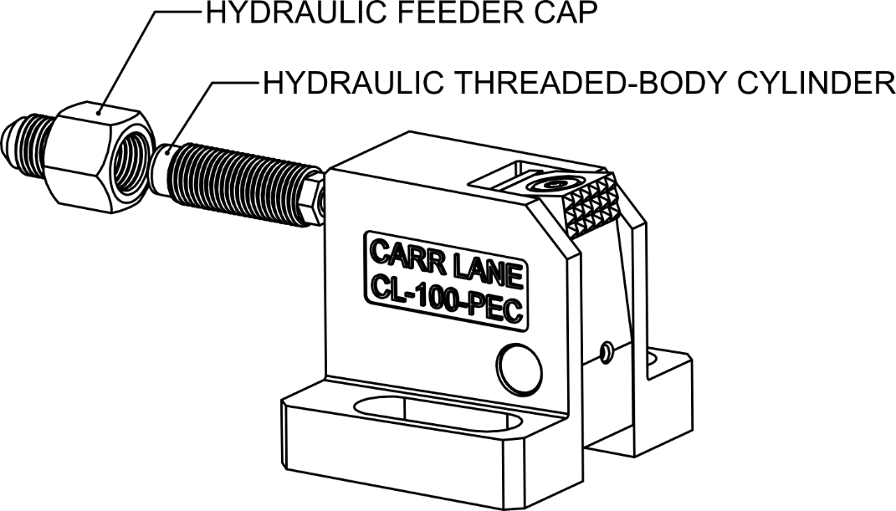

1. Install appropriate Feeder Cap onto ½-20 or M12 Threaded-Body Cylinder (Installation Torque, 7 ft-lbs).
2. Hand-Tighten Cylinder into Body. No significant torque required (7ft-lbs or less).
3. If the clamp will be subjected to substantial vibration use a non-permanent thread locker to ensure the cylinder does not vibrate.
4. Never exceed 7,250 psi hydraulic pressure.

Questions? Call 1-800-785-7821 or email [engineering@carrlane.com](mailto:engineering@carrlane.com)

***\*\*\* Always use this product in the manner intended as found in the Carr Lane Mfg. Catalog or at carrlane.com***